**2D and 3D graphics with OpenGL: 2D Geometric Transformations: Basic 2D Geometric Transformations, matrix representations and homogeneous coordinates, 2D Composite transformations, other 2D transformations, raster methods for geometric transformations, OpenGL raster transformations, OpenGL geometric transformations function**

### Geometric Transformations

Operations that are applied to the geometric description of an object to change its position, orientation, or size are called **geometric transformations**

Basic Two-Dimensional Geometric Transformations

##### Two-Dimensional Translation

* We perform a **translation** on a single coordinate point by adding offsets to its coordinates so as to generate a new coordinate position.
* We are moving the original point position along a straight-line path to its new location.
* To translate a two-dimensional position, we add **translation distances** *tx* and *ty* to the original coordinates (*x*, *y*) to obtain the new coordinate position (*x*’, *y*’) as shown in Figure

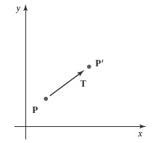

* The translation values of x’ and y’ is calculated as



* The translation distance pair (*tx*, *ty*) is called a **translation vector** or **shift vector Column vector representation is given as**

* This allows us to write the two-dimensional translation equations in the matrix Form



* Translation is a *rigid-body transformation* that moves objects without deformation.

##### **Two-Dimensional Rotation**

* We generate a **rotation** transformation of an object by specifying a **rotation axis** and a **rotation angle.**
* A two-dimensional rotation of an object is obtained by repositioning the objectalong a circular path in the *xy* plane.
* In this case, we are rotating the object abouta rotation axis that is perpendicular to the *xy* plane (parallel to the coordinate*z* axis)**.**
* Parameters for the two-dimensional rotation are the rotation angle *θ* anda position

(*xr*, *yr* ), called the **rotation point** (or **pivot point**), about which theobject is to be rotated

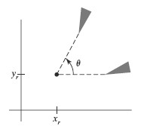

* A positive value for the angle *θ* defines a counterclockwise rotation about the pivot point,
* as in above Figure , and a negative value rotates objects in the clockwise direction.
* 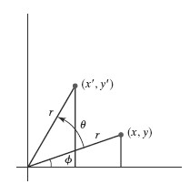The angular and coordinate relationships of the original and transformed point positions as Shown below fig.
* In this figure, *r* is the constant distance of the point from the origin, angle *φ* is the original angular position of the point from the horizontal, and *θ* is the rotation angle.
* we can express the transformed coordinates in terms of angles *θ* and *φ* as



* The original coordinates of the point in polar coordinates are 
* Substituting expressions of x and y in the eaquations of x’ and y’ we get
* We can write the rotation equations in the matrix form
  + - * **P**’ = **R**· **P**
    - Where the rotation matrix is,

**Two dimensional Scaling**

To change the size of an object, scaling transformation is used. In the scaling process, you either expand or compress the dimensions of the object. Scaling can be achieved by multiplying the original coordinates of the object with the scaling factor to get the desired result.

Let us assume that the original coordinates are X,Y , the scaling factors are (SX, SY), and the produced coordinates are X′,Y′X′,Y′. This can be mathematically represented as shown below –

**X' = X . SX and Y' = Y . SY**

The scaling factor SX, SY scales the object in X and Y direction respectively. The above equations can also be represented in matrix form as below –

**(X′Y′)=(XY)[Sx00Sy](X′Y′)=(XY)[Sx00Sy]**

OR **P’ = P . S**

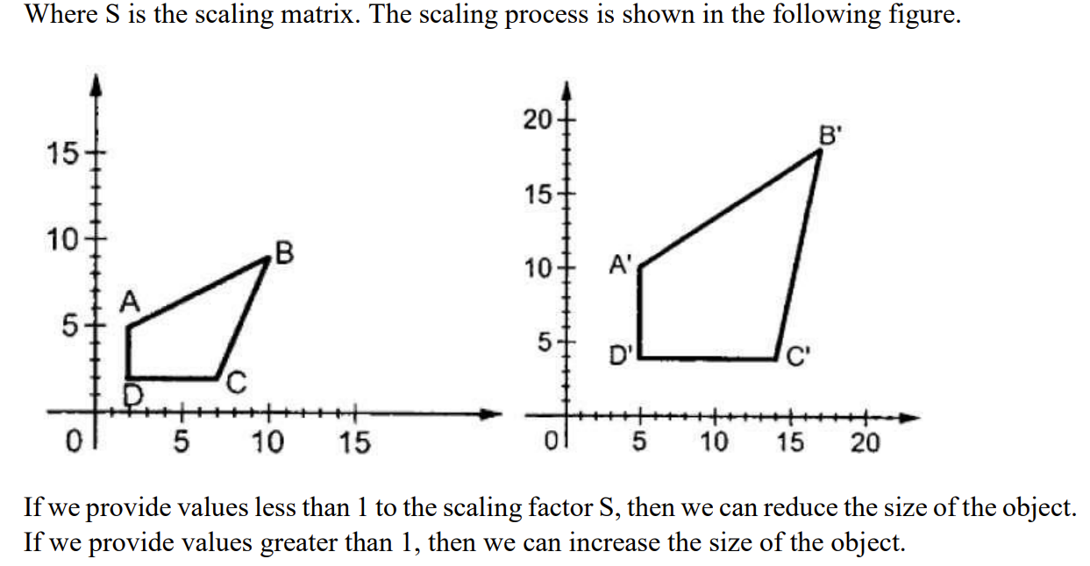

**Matrix Representations and Homogeneous Coordinates**